**DSA Assignment**

**Name:** Faizan **CMSID:** 023-23-0318

**Section:** A **Date:** 12-10-2024

**Lab 8 Solutions**

**Task 01**

. Write the recursion function DecimalToBinary, should return a string that stores the binary equivalent for int variable num.

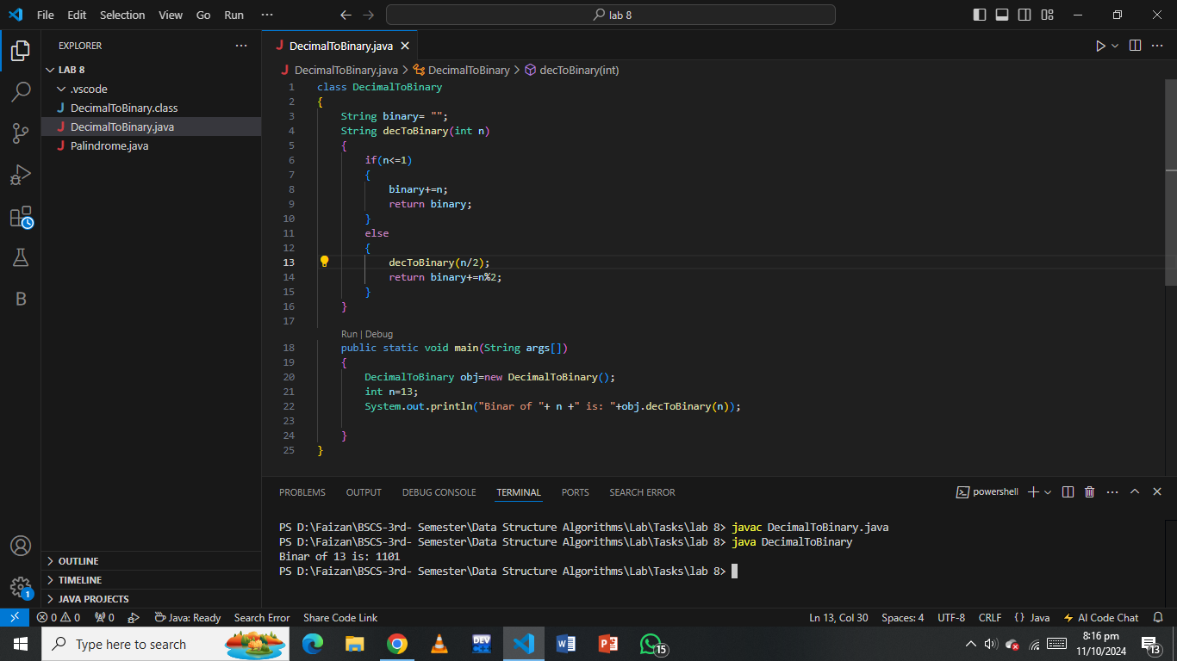

**Task 02**

Check for Palindrome (Recursive String Check): Implement a recursive function to check if a given string is a palindrome.

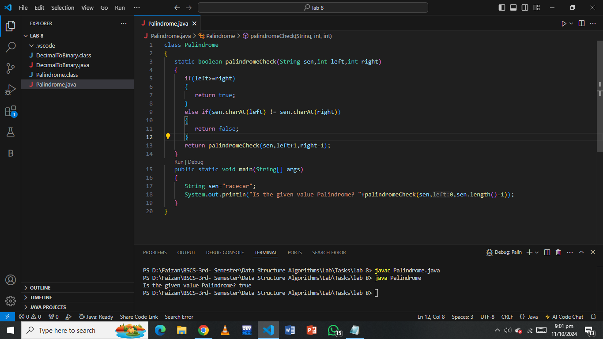

**Task 03**

(Undo/Redo Program)

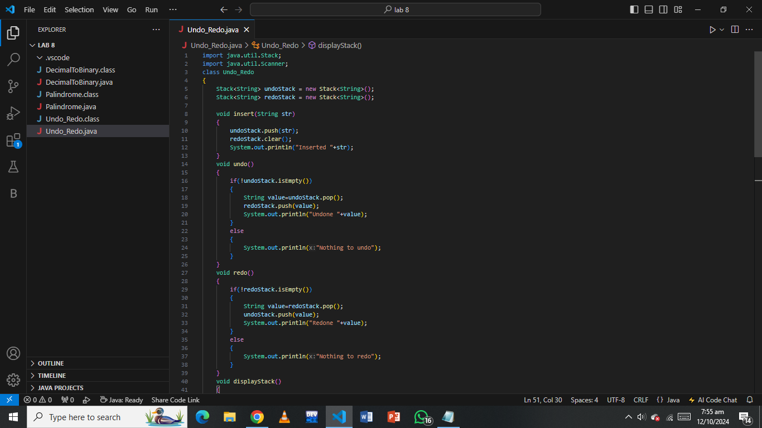

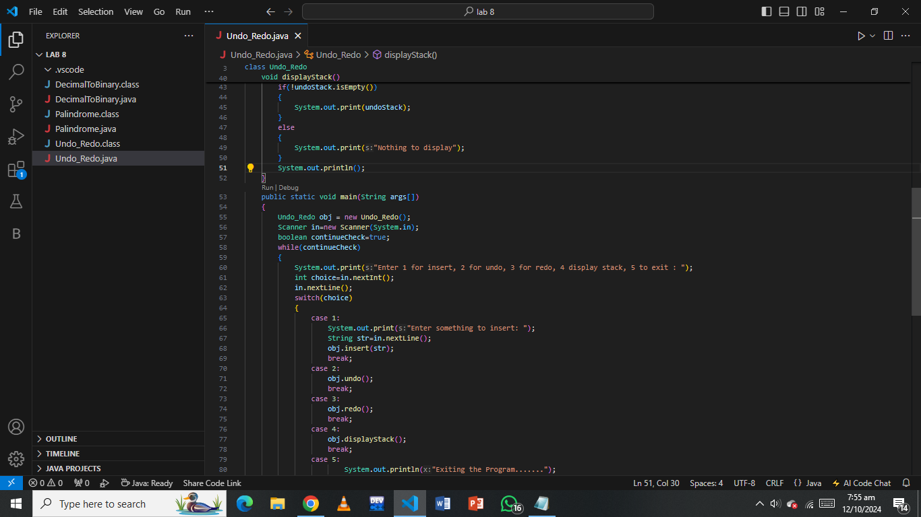

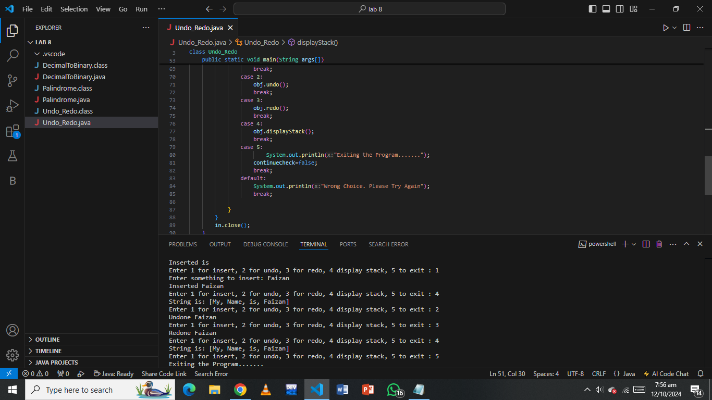

**Task 04**

Apply Greedy approach

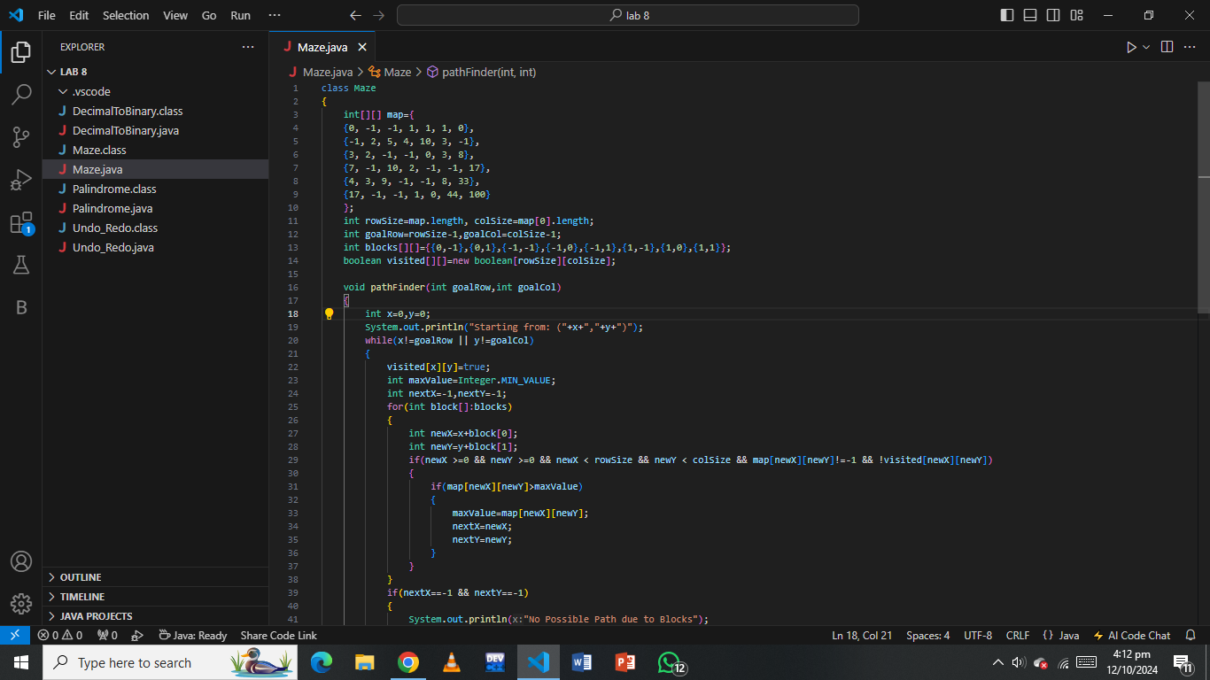

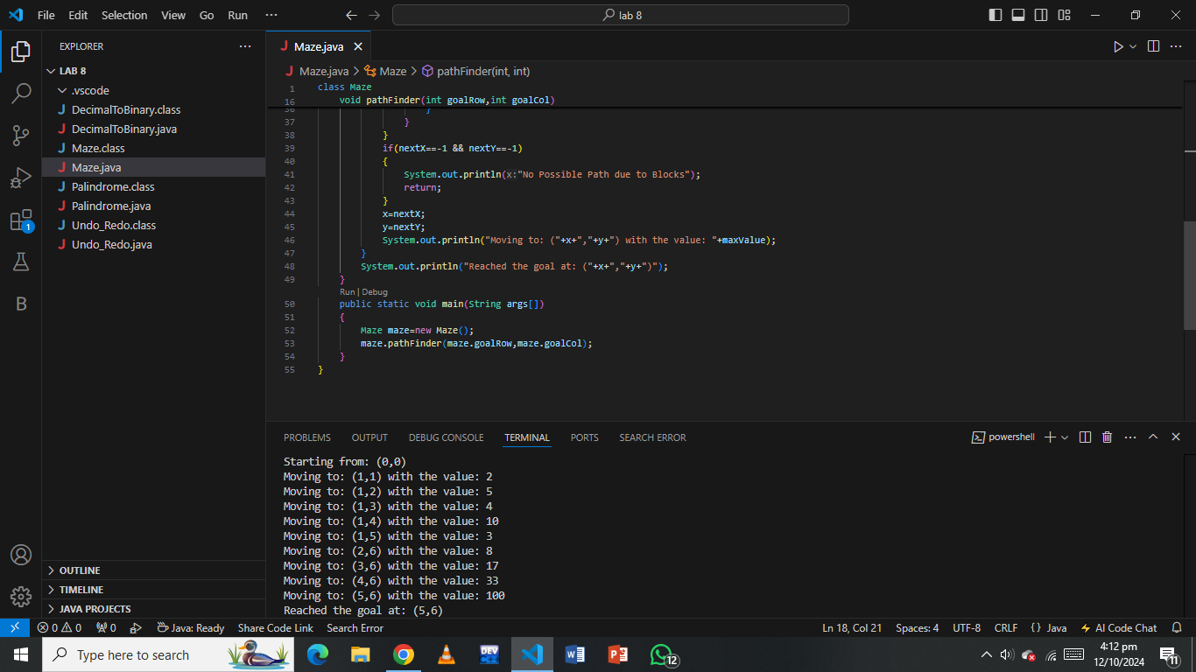

**Task 05**

Write a function that takes two sorted singly linked lists and merges them into one sorted linked list. The function should return the head of the merged list.

